**Experiment 4: Mux and Demux in Verilog**

Jyothiradithyan k

S3 CSE, 34.

**AIM**

(a) Development of Verilog modules for a 4x1 MUX.

**VERILOG CODE**

**Data flow level**

module mux(

input wire s0,s1,i0,i1,i2,i3,

output wire y);

assign y = (~s0)&(~s1)&i0 | (s0)&(~s1)&i1| (~s0)&(s1)&i2 | (s0)&(s1)&i3;

endmodule

**Testbench**

`timescale 1ns/1ps

module test_mux;

reg t_s0,t_s1,t_i0,t_i1,t_i2,t_i3;

wire t_y;

mux uut(.s0(t_s0),.s1(t_s1),.i0(t_i0),.i1(t_i1),.i2(t_i2),.i3(t_i3),.y(t_y));

initial

begin

$dumpvars(1,test_mux);

t_s1=1'b0;

t_s0=1'b0;

t_i0=1'b1;

t_i1=1'b0;

t_i2=1'b1;

t_i3=1'b0;

#10;

t_s1=1'b0;

t_s0=1'b1;

t_i0=1'b1;

t_i1=1'b0;

t_i2=1'b1;

t_i3=1'b0;

#10;

t_s1=1'b1;

t_s0=1'b0;

t_i0=1'b1;

t_i1=1'b0;

t_i2=1'b1;

t_i3=1'b0;

#10;

t_s1=1'b1;

t_s0=1'b1;

t_i0=1'b1;

t_i1=1'b0;

t_i2=1'b1;

t_i3=1'b0;

#10;

$stop;

end

endmodule

**Output**

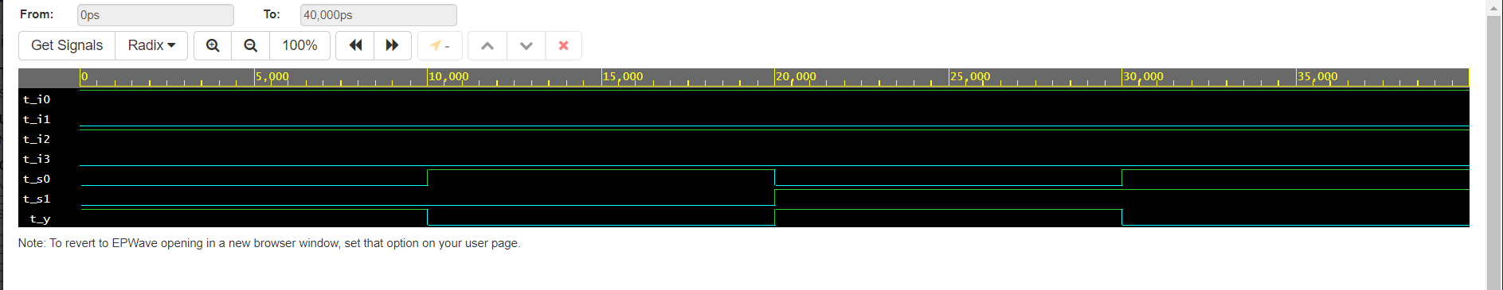

**AIM**

(b) Development of Verilog modules for a 1x4 DEMUX.

**VERILOG CODE**

**Data flow level**

module demux(

input wire s0,s1,d,

output wire y0,y1,y2,y3);

assign y0 = (~s1)&(~s0)&d;

assign y1 = (~s1)&(s0)&d;

assign y2 = (s1)&(~s0)&d;

assign y3 = (s1)&(s0)&d;

endmodule

**Testbench**

`timescale 1ns/1ps

module test_demux;

reg t_s0,t_s1,t_d;

wire t_y0,t_y1,t_y2,t_y3;

demux uut(.s0(t_s0),.s1(t_s1),.d(t_d),.y0(t_y0),.y1(t_y1),.y2(t_y2),.y3(t_y3));

initial

begin

$dumpvars(1,test_demux);

t_s0=1'b0;

t_s1=1'b0;

t_d=1'b1;

#10;

t_s0=1'b1;

t_s1=1'b0;

t_d=1'b1;

#10;

t_s0=1'b0;

t_s1=1'b1;

t_d=1'b1;

#10;

t_s0=1'b1;

t_s1=1'b1;

t_d=1'b1;

#10;

$stop;

end

endmodule

**Output**

